How to run&debug qt5 application with qt creator
1. Compile plugin as described in README.md. Compiled library will be at ./plugins/platforms/libqthtml.so
2. Open in Qt Creator any Qt5 UI application, for example – https://github.com/selairi/mdiedit.
3. Build project.
4. Copy libqthtml.so to build directory of project, where is located build directory can be found in Project Settings->Build tab->Build directory
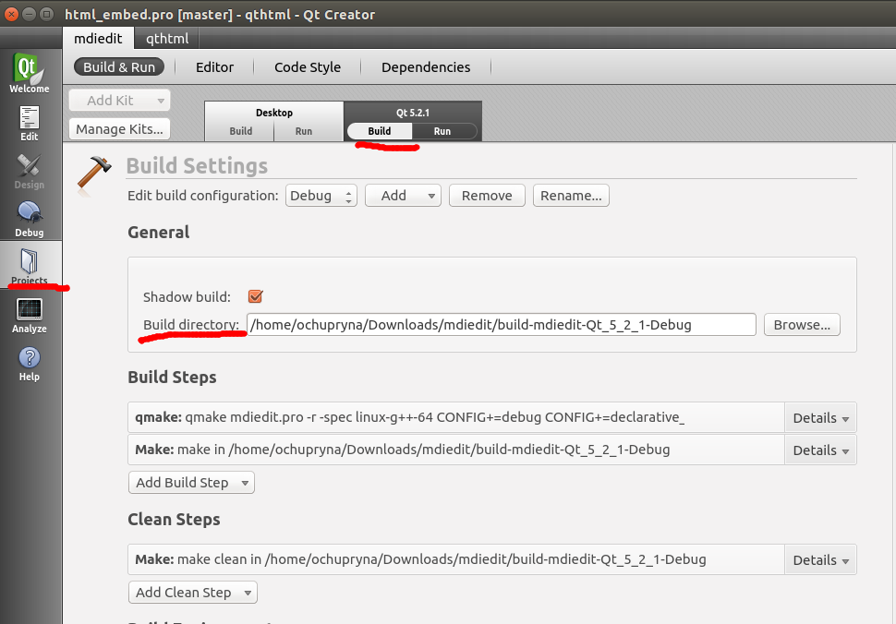
5. Go to Project Settings->Run tab->Run Environment and set QT_QPA_PLATFORM_PLUGIN_PATH to “.”. Also it is necessary to enter data in Arguments textfield “-platform html” - it is indication to use qthtml plugin as graphical backed for qt5 application.

